FOR IMMEDIATE RELEASE – APRIL 13, 2022
Media contact: Sarah Dunn, sarahd@glatzconcerts.com, 416-561-3734

Attila Glatz Concert Productions and TO Live present

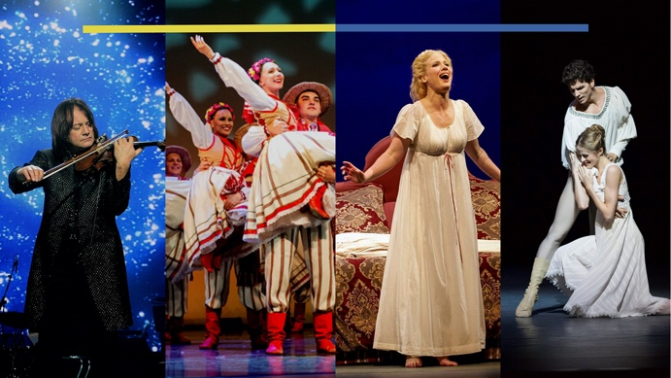
UNITED FOR UKRAINE
Benefit for Canada-Ukraine Foundation

Thursday, April 28, 7:30 p.m.
Meridian Hall
Toronto

TORONTO, ON (Wednesday, April 13, 2022)—Attila Glatz Concert Productions and TO Live are proud to present United for Ukraine, a night of music and dance in support of those affected by the ongoing crisis in Ukraine. Conceived and curated by Sonia Rodriguez, Heather Ogden, Evelyn Hart, and Attila Glatz, all of the net proceeds from this event will be donated to Canada-Ukraine Foundation, an organization that supports Ukrainian families displaced from their homes.

“The performing arts represent a real global community,” says Sonia Rodriguez, co-curator of this benefit. “I’ve spent a career performing alongside people from all over the world, and felt a genuine need to do whatever possible to support the people of Ukraine in this time of crisis.”

Emceed by Carolyn MacKenzie and Jeff McArthur, hosts of Global’s The Morning Show, United for Ukraine will feature a dynamic and varied program of music and dance by acclaimed artists across genres and disciplines. “We’re honoured to co-present this benefit in support of the people of Ukraine, and to showcase the work of incredible performing artists lending their talents to this noteworthy cause,” says Clyde Wagner, President and CEO of TO Live. “Seeing the arts community come together like this is inspiring and TO Live is proud to help share this event with audiences in Toronto.”

Performers for the evening will include:
- Superstar Ukrainian violin virtuoso Vasyl Popadiuk and the Papa Duke Band;
- Prima ballerina Sonia Rodriguez with principal dancers of the National Ballet of Canada: Guillaume Côté, Heather Ogden, Svetlana Lunkina, Brendan Saye, Jurgita Dronina, Harrison James, and First Soloist Spencer Hack;
- Ukrainian dance company Kalyna Performing Arts Company;
- Indigenous dance company Red Sky Performance;
- Canada’s preeminent Ukrainian Women’s Choir, Vesnivka;
- Opera singers Lara Ciekiewicz, Natalya Gennandi, and James McLennan;
- Dancers from Barvinok Ukrainian Dance School

Speaking from his own experience, co-presenter Attila Glatz explains his motivation for participating in this benefit: “I was a young boy living in Hungary at the time of the 1956 uprising among incredible political unrest under Russian occupation. I escaped to the west in 1968, and fast-forward to the present…the fact that we present concerts in a country where we don’t have to worry for our safety shows how fortunate we are. We have a real opportunity now – 3,200 of us do – to come together at Meridian Hall on April 28 to show our solidarity with the people of Ukraine.”

Tickets are on sale for United for Ukraine
Today, April 13, at 10 AM:
https://tolive.com/Event-Details-Page/reference/United-for-Ukraine

Support for this event is critical to the families of Ukraine. For individuals or organizations looking to sponsor this event and/or make a donation please contact Sandra Bellisario, sandra.bellisario@tolive.com or 416-414-0341.

###

About Attila Glatz Concert Productions
Attila Glatz Concert Productions produces, promotes, and manages classical, jazz, folk, country, movie, and video game music performances worldwide. The company’s signature presentation is the beloved Salute to Vienna New Year’s Concert, presented annually in more than 20 cities across North America during the holiday season. Salute to Vienna was recreated at Vienna’s Konzerthaus for PBS featuring more than 130 performers, and this concert has aired across North America on public television more than 21,000 times. Other company highlights include the North American tours of the Vienna Mozart Orchestra, and David Foster, as well as a cinematic concert series with films including the Harry Potter Film in Concert series, Ghostbusters, Amadeus, and Jurassic Park.

About TO Live
Previously known as Civic Theatres Toronto, TO Live is one of the Canada’s largest multi-arts organizations, operating three iconic venues and presenting a full range of performing arts, theatrical and concert events in both downtown and uptown Toronto at Meridian Hall (formerly the Sony Centre), St. Lawrence Centre for the Arts, and Meridian Arts Centre (formerly the Toronto Centre for the Arts). With two hubs of creativity and content creation in both downtown and uptown Toronto, TO Live has a unique place and perspective in Toronto. The purpose of TO Live is to amplify the role of performance spaces as a force for social engagement, cultural exchange, and creative innovation.

For interviews please contact:
Sarah Dunn, sarahd@glatzconcerts.com, 416-561-3734

